Lab 2 - Bayesian Statistics - Distributional Theory

Daniel Carpenter

January 2022

Table of Contents

# 1 Discrete Binomial Distribution

*Note* that the discrete binomial distribution is very useful for modeling processes in which the binary outcome can be ***either*** a success (1, TRUE) or a failure (0, FALSE)

### 1.0.1 LaTex Formula for Discrete Binomial Distribution

$$p(X=x|n,p)=\left(\begin{matrix}N \\ k\end{matrix}\right)p^{k}(1−p)^{N−k}$$

### 1.0.2 Function (dmybin) to Calculate Discrete Binomial Distribition

dmybin <- function(X, n, p) {  
   
 # Change X to k to be consistent with textbook  
 k = X  
   
 # Calculate the binomial coefficient (N k)  
 binomialCoefficient <- choose(n, X)  
   
 # Return the discrete binomial calculation  
 return(binomialCoefficient * p^k * (1 - p)^(n - k))  
}

### 1.0.3 Call and Return Results of the dmybin Function

y.dmybin = dmybin(X=0:4, n=10, p=0.5)  
y.dmybin

## [1] 0.0009765625 0.0097656250 0.0439453125 0.1171875000 0.2050781250

### 1.0.4 Call and Return Results of base R Binomial Distribution Function dbinom

y.dbinom = dbinom(x=0:4, size=10, prob=0.5)  
y.dbinom

## [1] 0.0009765625 0.0097656250 0.0439453125 0.1171875000 0.2050781250

### 1.0.5 Create a Cumulative Probability Function Called pmybin

pmybin <- function(dmybin, x, n, p) {  
   
 # Return the Cumulative Probability  
 return(sum(dmybin(0:x, n, p)))  
}

### 1.0.6 Call and Return Results of the pmybin

cumulativeProbability.pmybin <- pmybin(dmybin, x=5, n=10, p=0.5)  
cumulativeProbability.pmybin

## [1] 0.6230469

### 1.0.7 Call and Return Results of base R Binomial Function Distribution Function pbinom

cumulativeProbability.pbinom <- pbinom(q = 5, size=10, prob=0.5)  
cumulativeProbability.pbinom

## [1] 0.6230469

### 1.0.8 Create a Binomial Distribution Plot

x = 0:10  
  
plot(x,   
 y = dbinom(x, size = 10, prob = 0.5),  
 type = 'h', # h := histogram like  
 main = 'Daniel Carpenter - Binomial Distributon',  
 xlab = 'x')

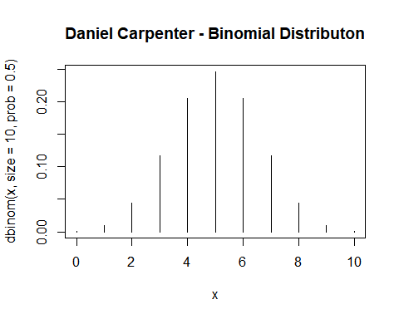

# 2 Poisson and Four Basic Distributional Functions: dpois, ppois, rpois, and qpois

## 2.1 a Poisson Calculations

### 2.1.1 Find 𝑃(𝑋 = 4|𝜆 = 3)

* What is the probability that there are exactly 4 successes when 3 is the average?

dpois(x = 4, lambda = 3)

## [1] 0.1680314

### 2.1.2 Find 𝑃(𝑋 ≤ 4|𝜆 = 3)

* What is the probability that there are 4 or less successes when 3 is the average?

ppois(q = 4, lambda = 3)

## [1] 0.8152632

### 2.1.3 Find 𝑃(𝑋 > 4|𝜆 = 3)

* What is the probability that there are more than 4 successes when 3 is the average?

ppois(q = 4, lambda = 3, lower.tail = FALSE)

## [1] 0.1847368

### 2.1.4 Find x so that 𝑃(𝑋 ≤ 𝑥|𝜆 = 3)= 0.9997077

* How many successes when 3 on average and cumulative probability of 0.9997077?

qpois(p = 0.9997077, lambda = 3)

## [1] 11

### 2.1.5 Create a sample of size 100 from a Poisson distribution that has parameter 𝜆 = 3. Store in an object.

poissonSample3 <- rpois(n = 100, lambda = 3)

### 2.1.6 Make a second sample of size 100 from a Poisson that has parameter 𝜆 = 6, store in an object

poissonSample6 <- rpois(n = 100, lambda = 6)

## 2.2 b/c Data Frame and Base ggplot for Boxplots and Violins

if(!require(tidyverse)) install.packages(tidyverse)  
  
# Create data frame with both samples  
df <- data.frame(Fst = poissonSample3,  
 Snd = poissonSample6) %>%  
   
 # Pivot data into single column for ggplot use  
 pivot_longer(cols = c("Fst", "Snd"),  
 names_to = "Sample",  
 values_to = "x")  
  
  
# Create a base Plot Object for future distribution graphs  
basePlot <- ggplot(df,  
 aes(x = Sample,  
 y = x,  
 fill = Sample)) +   
   
 # Color palette and theme  
 scale_fill_brewer(palette = "Pastel1") +  
 theme_minimal() +  
   
 # Title  
 labs(title = 'Sample Distribution Created from rpois Poisson Function',  
 subtitle = 'Sample Size (n) = 100 | Fst Lambda = 3; Snd Lamda = 6')

## 2.3 b Create Box Plots

basePlot + geom_boxplot()

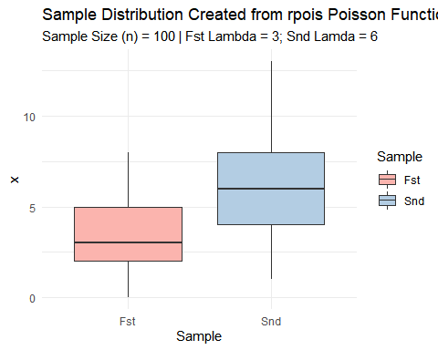

## 2.4 c Create Violin Plots

basePlot + geom_violin()

